Southside Travellers Action Group - Women Group
Trailer Project
Southside Traveller Action Group launched its ‘Days Long Gone’ Trailer Project on 10 June 2017 in the Lexicon Library, Dun Laoghaire as part of Traveller Pride Week 2016.
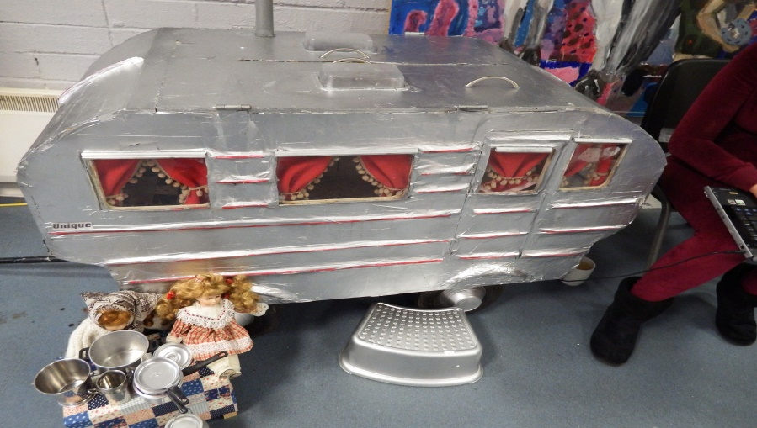

Over the months leading up to the launch, women from Southside Travellers Chill Out Zone were supported by an arts worker to recreate a Traveller trailer from back in the 1970’s.

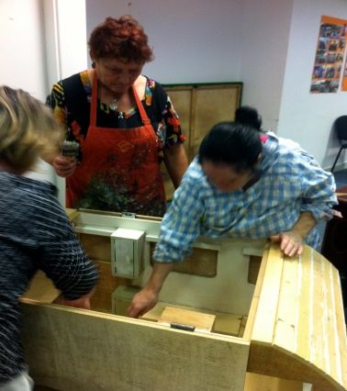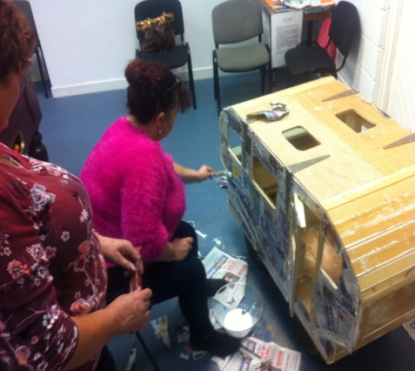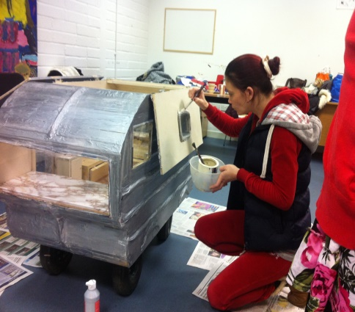

The Group designed and built the trailer from scratch and hand made all of the interior furnishings.
‘Days Long Gone’ also featured recordings of Traveller women recalling days of old on the road and traditional nomadic ways of living. They spoke of the freedom and peace; the harmony, solidarity and sense of plenty.
They discussed the situation as it stands today where there is little space or provision for a nomadic culture and how Travellers are being forced to move into settled housing.
The women talked of the loss of freedom, the loneliness, the separation from friends and family and the impact of this loss and isolation on health, particularly mental health.
They expressed their fears that Traveller culture is being wiped out and highlight the importance of passing on Traveller ways to the younger generation.
The group want ‘Days Long Gone’ to be a celebration of Traveller ways, to create a space for Travellers to reflect and remember days on the road and to create a space for the settled community to learn and understand the importance of travelling in Traveller culture.
Since the launch of the project, the trailer has been exhibited at UCD and is currently doing a tour of the country. On Friday 13 October, it will be on display at the County Hall on Marine Road in Dun Laoghaire, as part of the Festival of Inclusion – a festival to celebrate and promote the activities of community groups and volunteers in Dun Laoghaire-Rathdown.
There is further mileage left in the trailer and more events are planned for the future.

